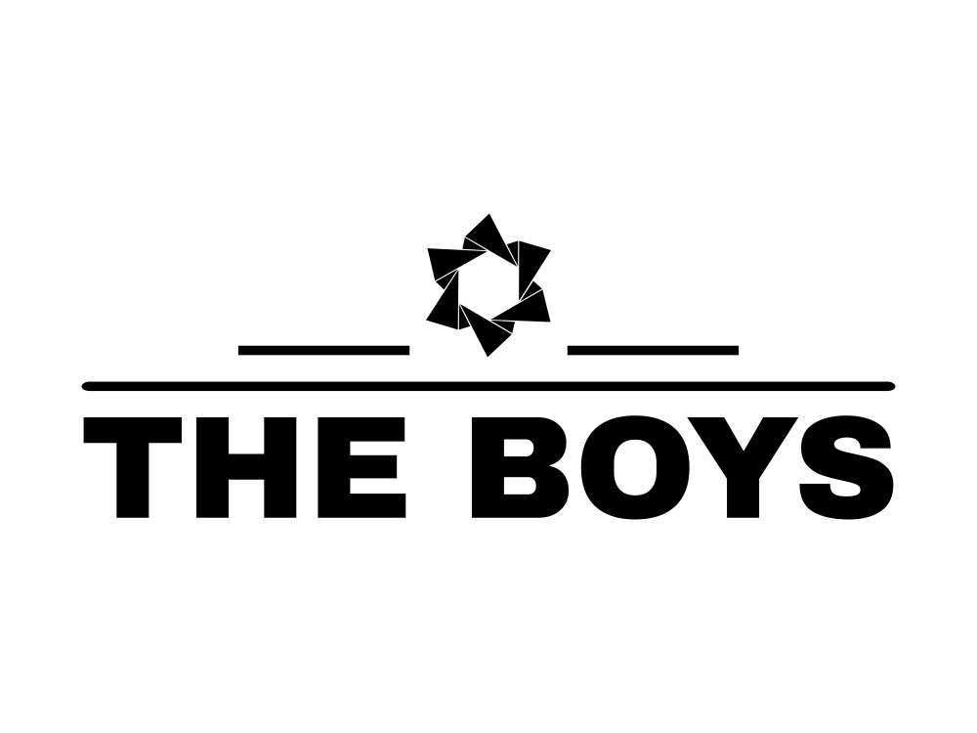

**The boys**

**Table of Contents**

Team 2

Goal 2

Task 2

Technologies and languages used 3

# **Team**

The people, which are a part of this project, are:

* Denis Kolev, 10V class, Scrum Trainer
* Bozhidar Boyadzhiev, 10V class, Backend Developer
* Mario Zlatev, 10V class, Backend Developer
* Georgi Zhekov, 10V class, Backend Developer
* Kliment Tenev, 10G class, Designer

# **Goal**

The main goal of our game is to create a fun experience for the user, while operating on three different characters in three different levels that each unlock after the previous one is completed. In the future, we can add more level and make the game better.

# **Task**

We made a meeting and decided on the idea. We created a design and started working on the game. Although there were some issues at first, we managed to succeed with our task.

# **Technologies and languages used**

* Teams
* Visual Studio Code
* MS Word
* MS PowerPoint
* JSON
* Raylib
* C++